Introduction to xilinx ise and spartan 6 board
LAB # 04



Spring 2024
CSE-308L Digital System Design Lab

Submitted by: Ali Asghar
Registration No.: 21PWCSE2059
Class Section: C

“On my honor, as student of University of Engineering and Technology, I have neither given nor received unauthorized assistance on this academic work.”

Submitted to:
Dr. Asif Ali Khan

Date:
22nd March 2024

Department of Computer Systems Engineering
University of Engineering and Technology, Peshawar
Objectives:
This lab will enable students to:
- Introduction to FPGA
- Introduction to Xilinx ISE

Software used:
- Xilinx ISE

Task 1:
Develop a program to control on Board LED using On board available switch.

Code:
DUT:
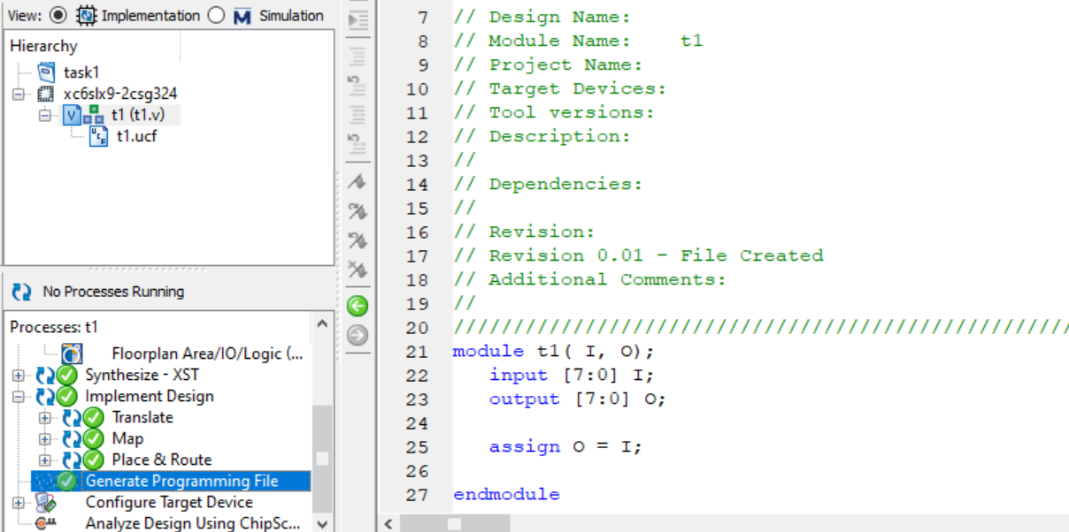

ucf file:
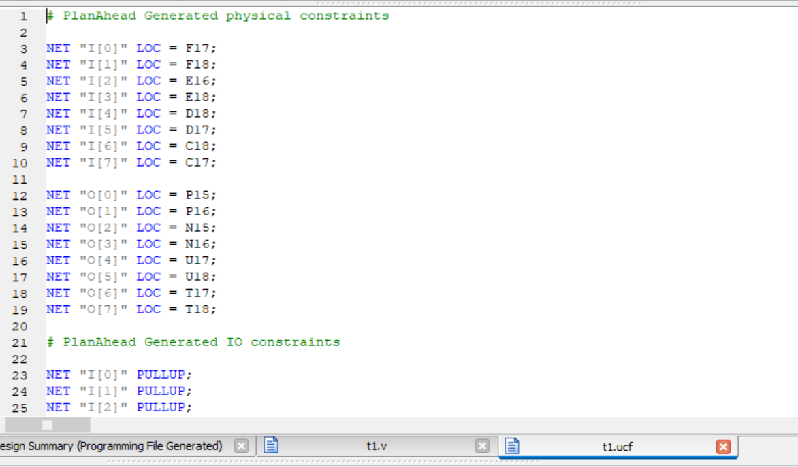
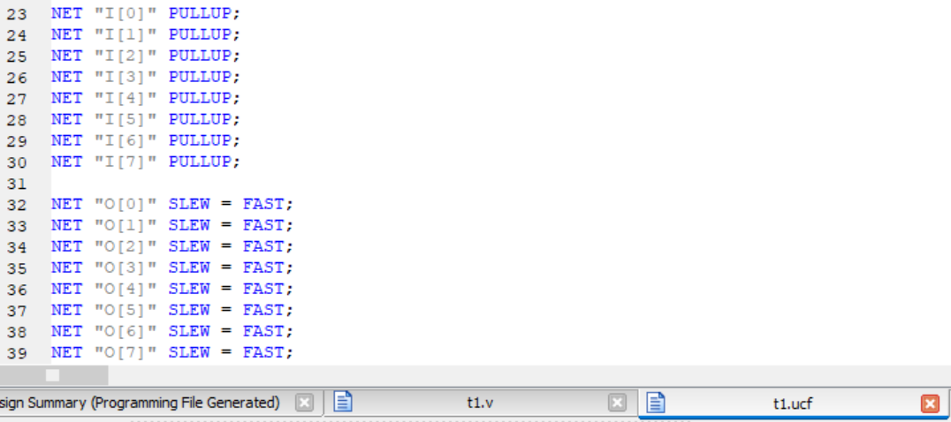

Output:
All the dip switches represent I while LEDs represent O.
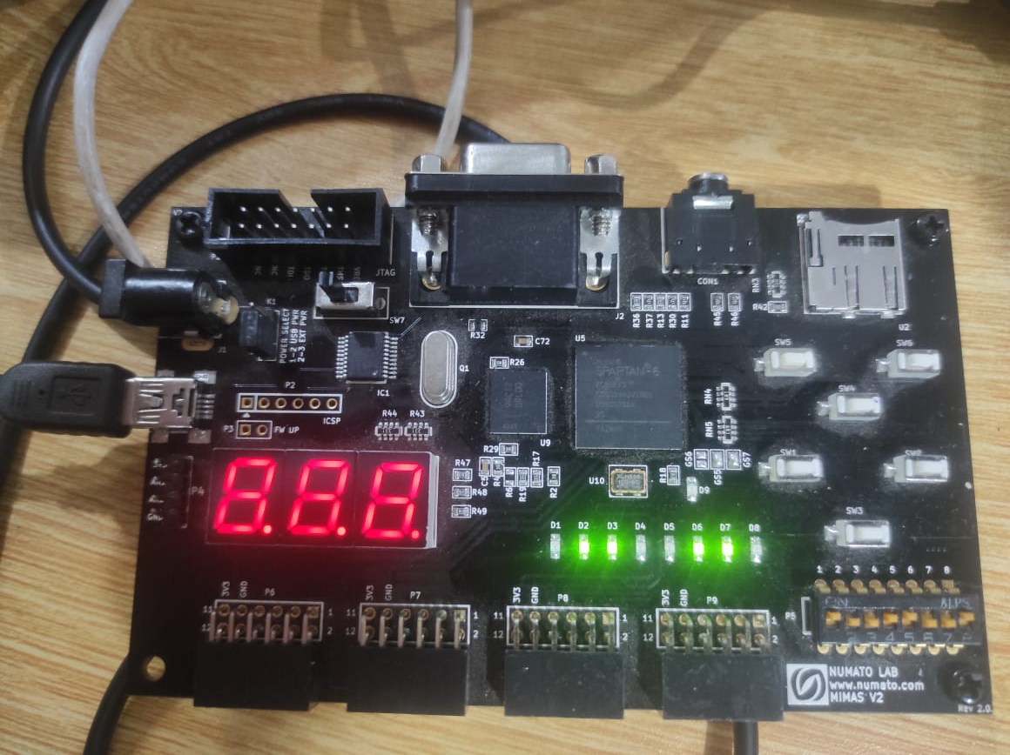
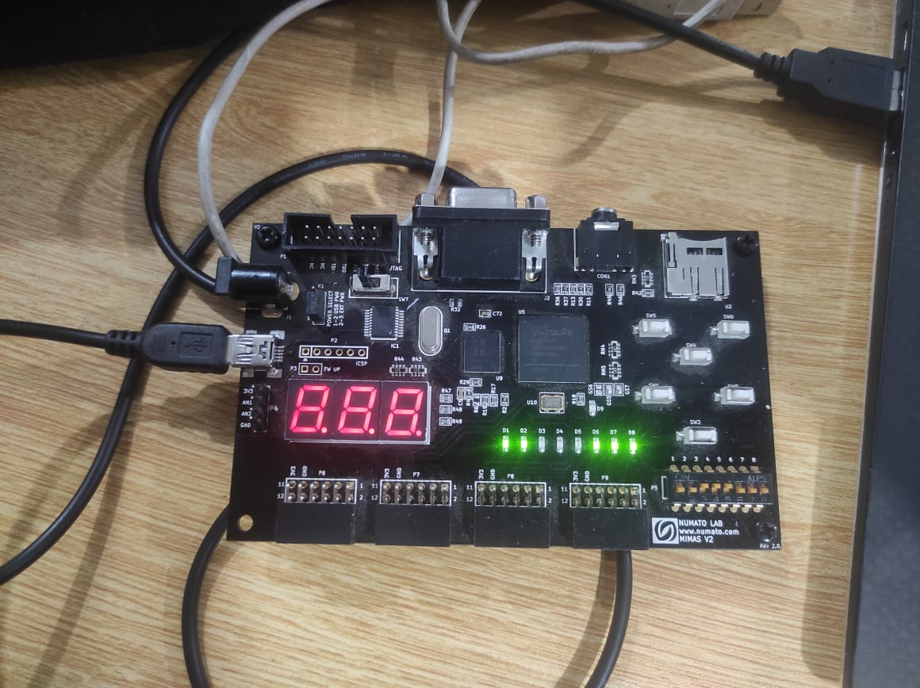

Task 2:
Develop a program that implements a 2x1 multiplexer on the board. Connect the inputs to switches and output to led.

Code:
DUT:
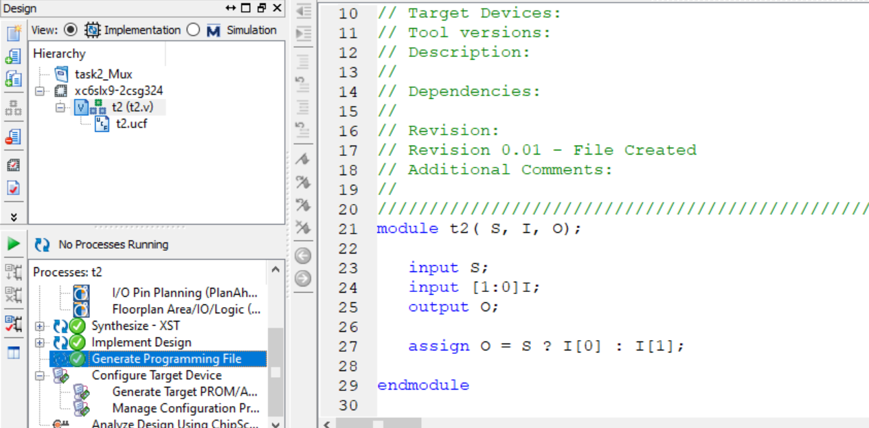

ucf file:
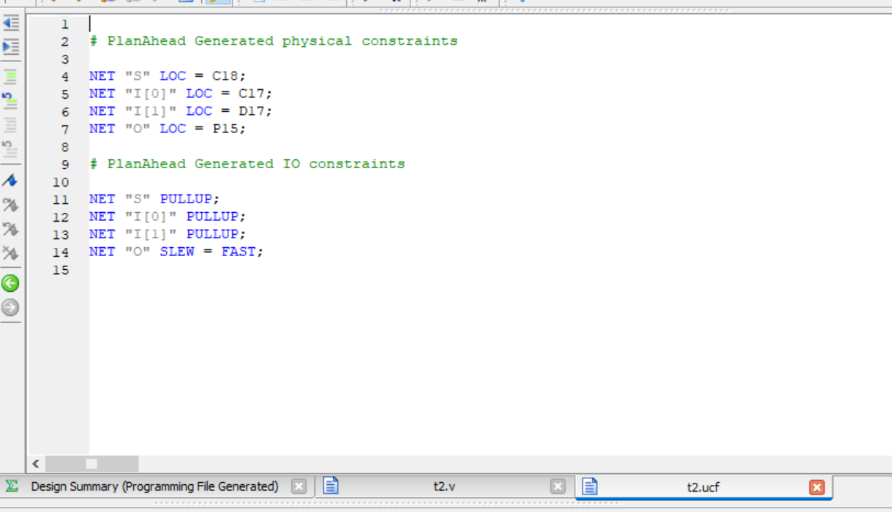

Output:
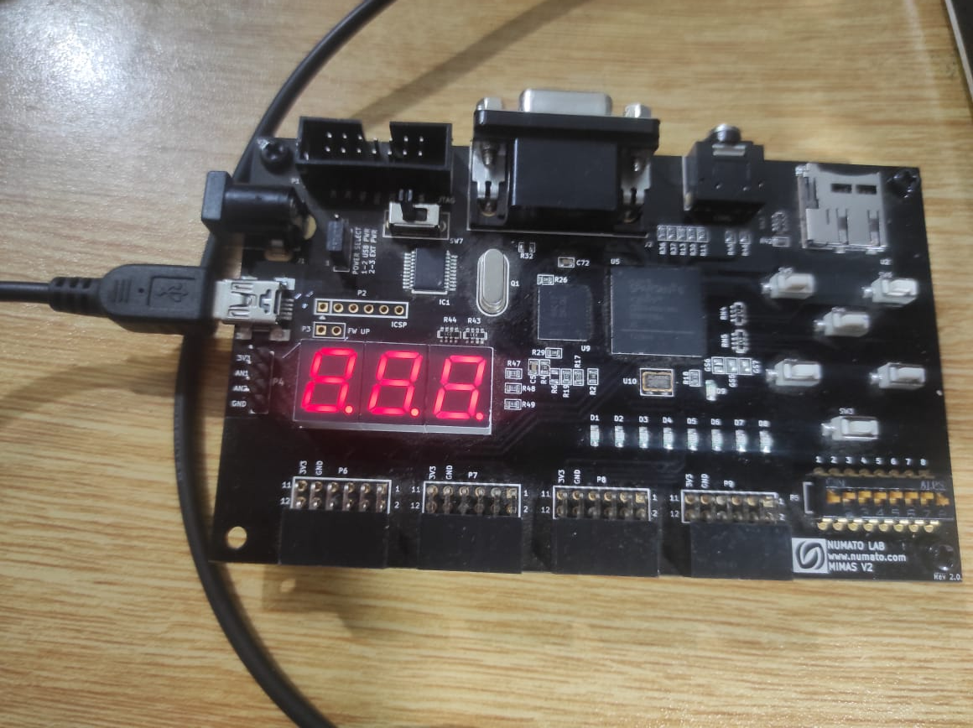
O
I[0]
S
I[1]

Task 3:
Develop a program that implements a 4x1 multiplexer on the board. Connect the inputs to switches and output to led

Code:
DUT:
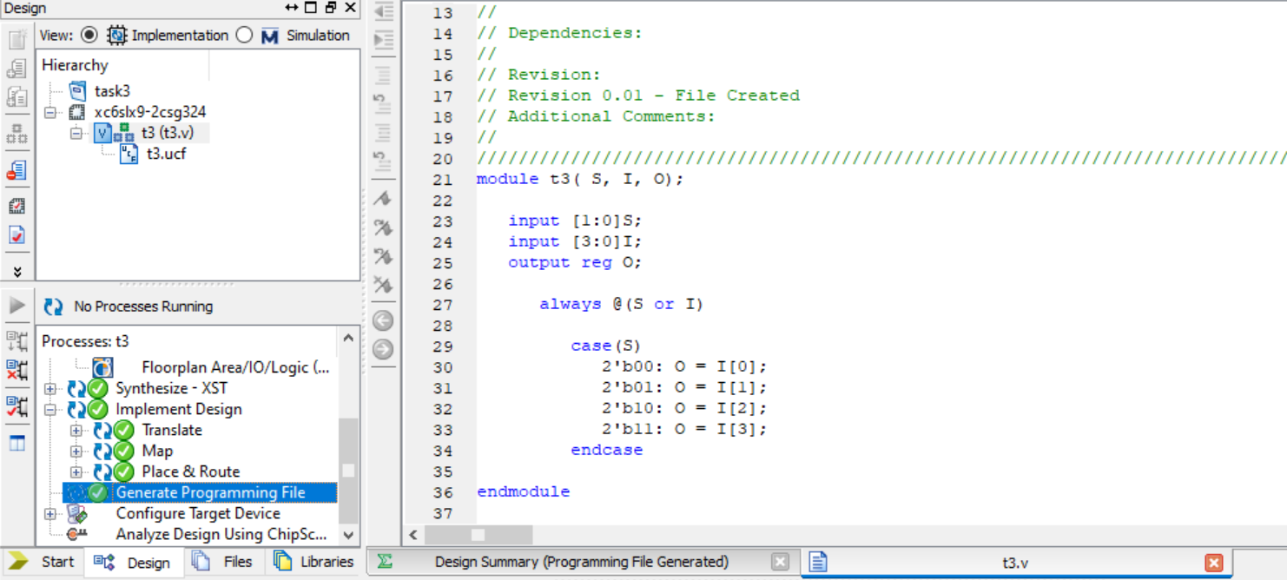
ucf file:
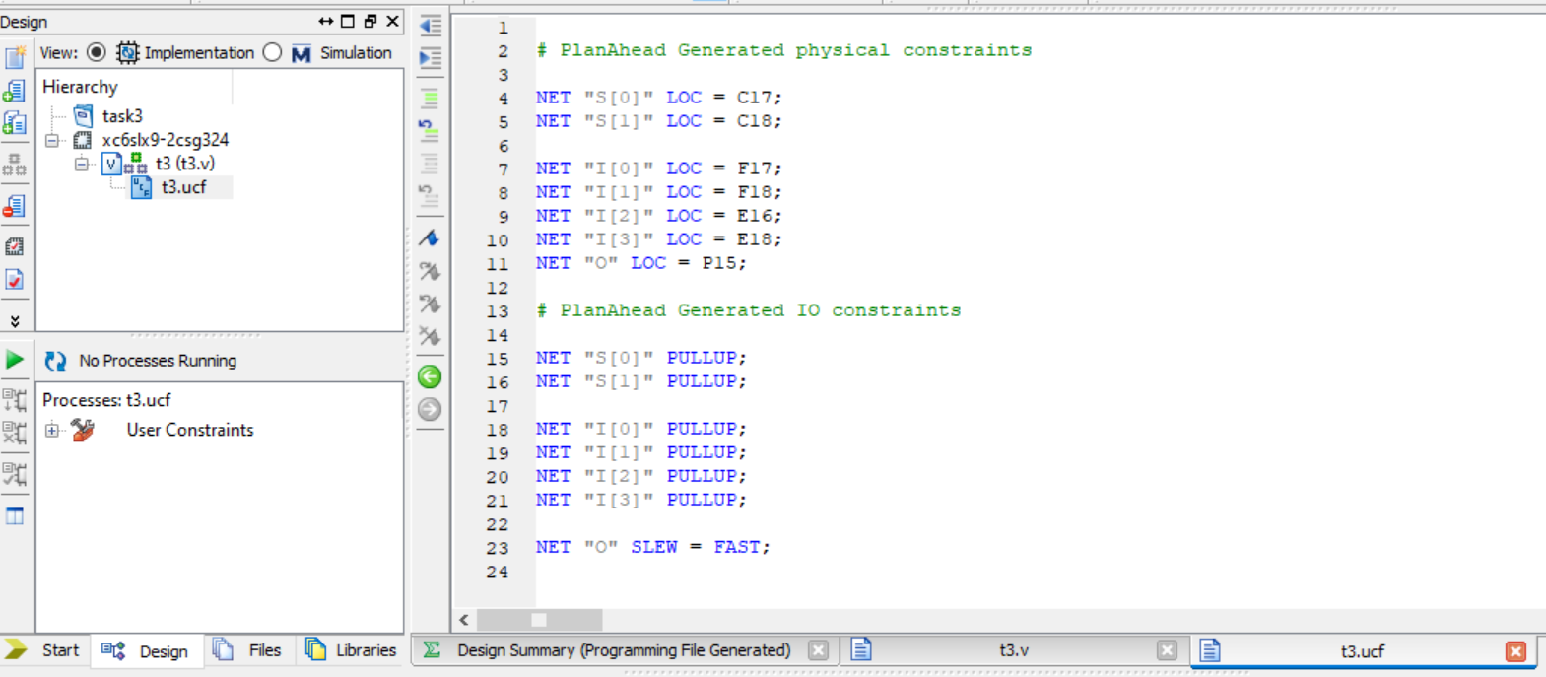

Output:
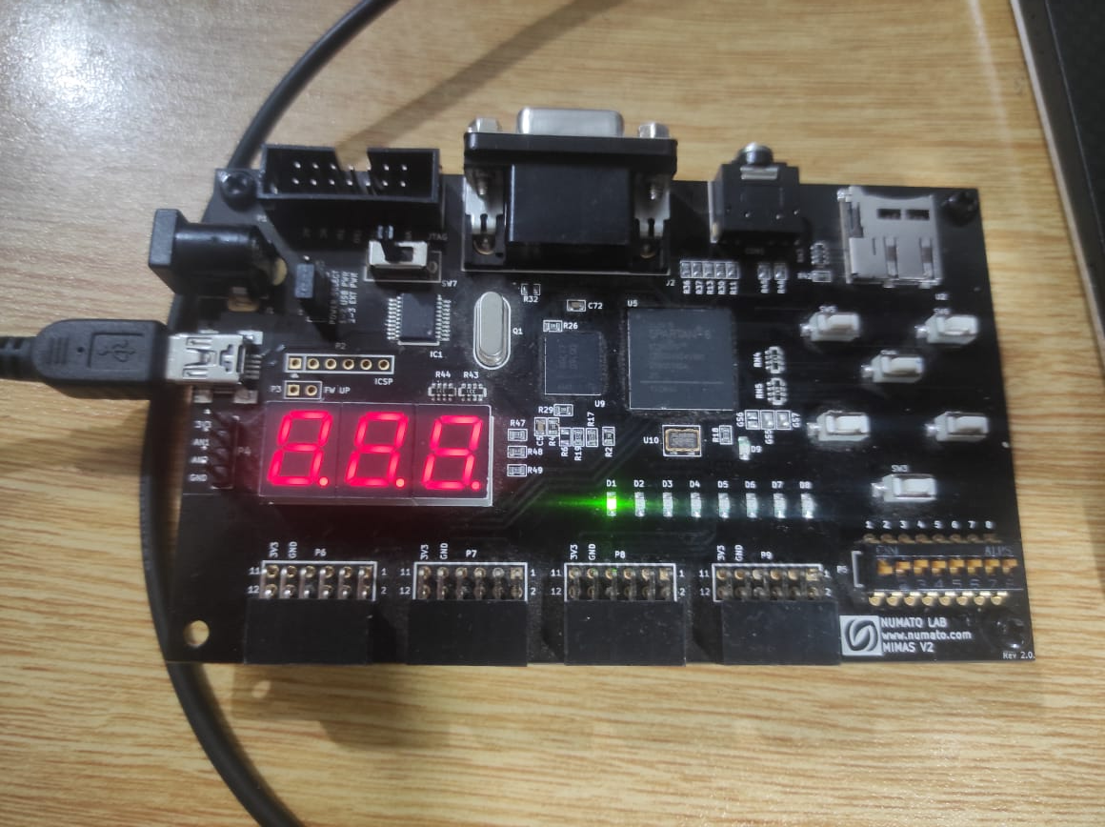
O
S[0]
I[3]
I[1]
I[0]
I[2]
S[1]

